Network Testing and Validation Guide
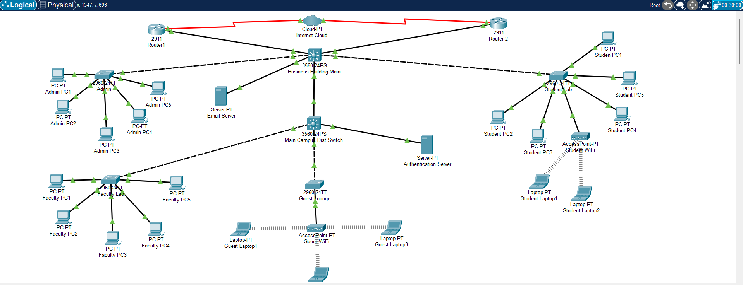
This document provides the step-by-step procedures to verify full functionality of the network.
1. VLAN and Trunk Verification
Run the following commands on every switch to verify VLANs and trunks:
- Business Building Main Switch
  - Show vlan brief and Show interfaces trunk
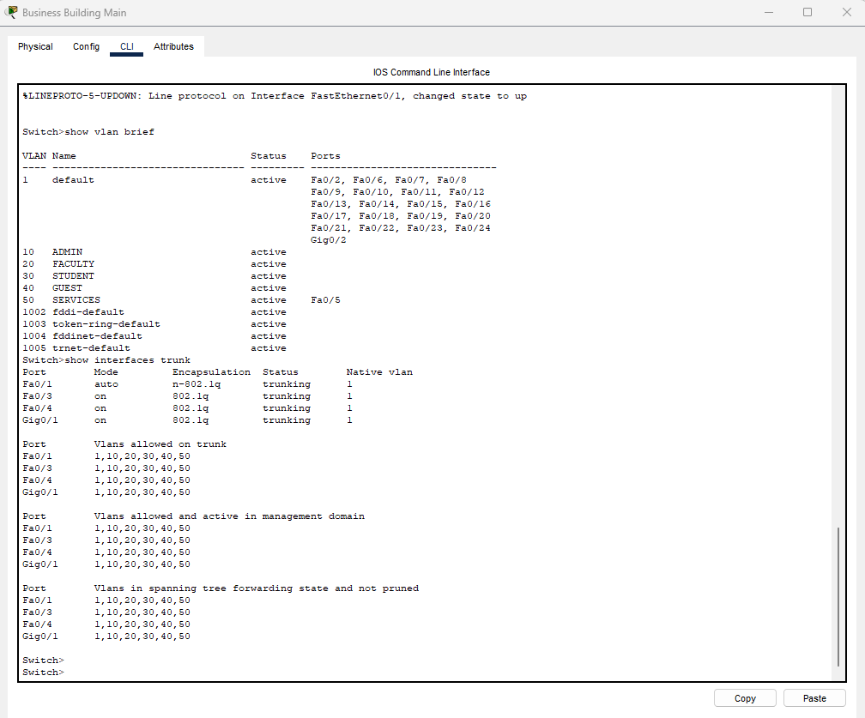

- Main Campus Dist Switch
  - Show vlan brief and Show interfaces trunk
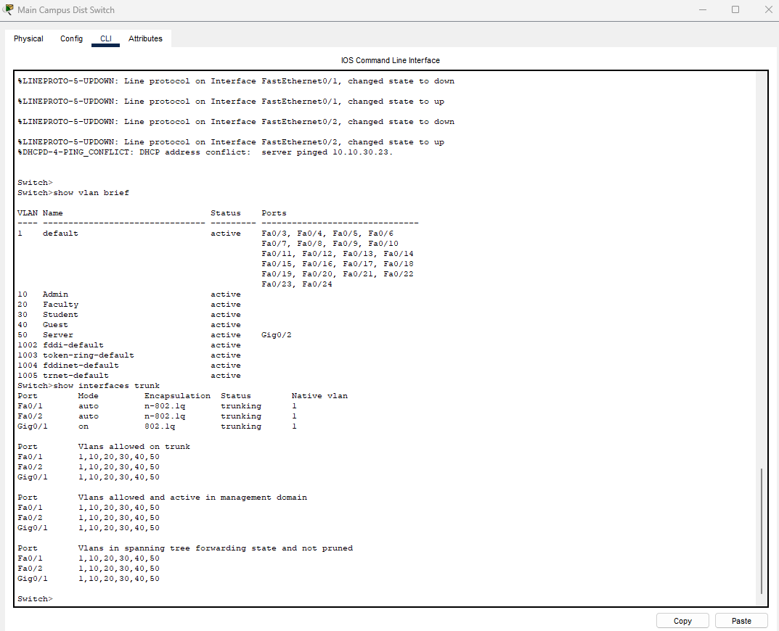

2. DHCP Verification
Ensure each VLAN is receiving DHCP addresses from the Main Campus Dist switch.
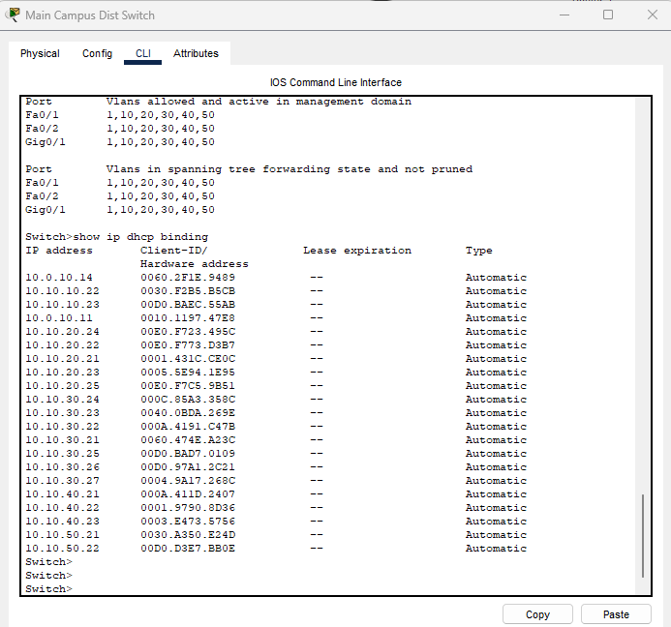

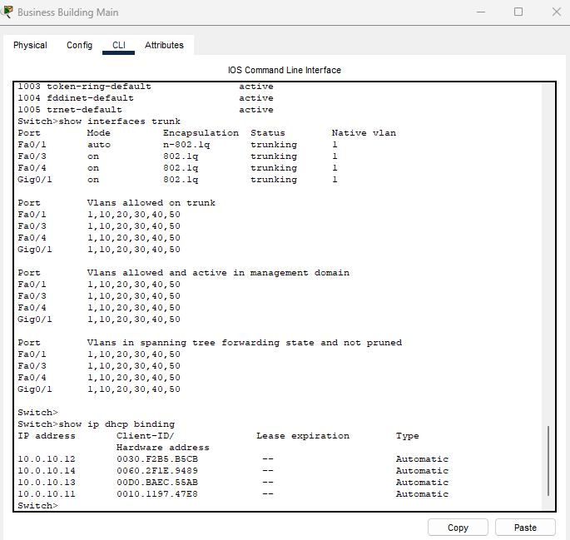

Expected DHCP Ranges:
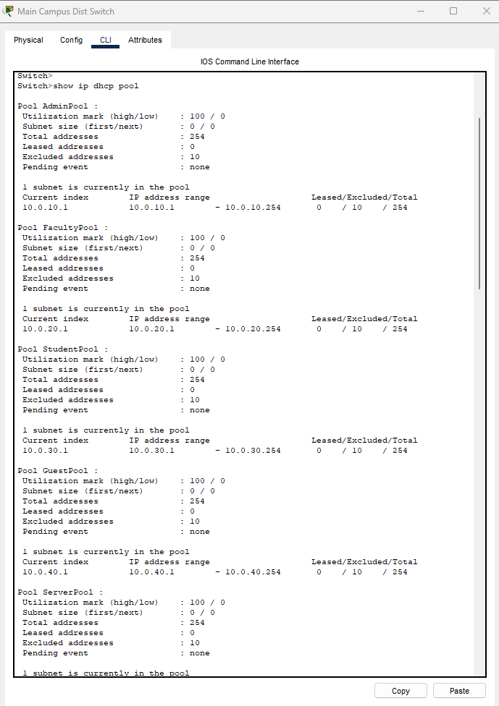
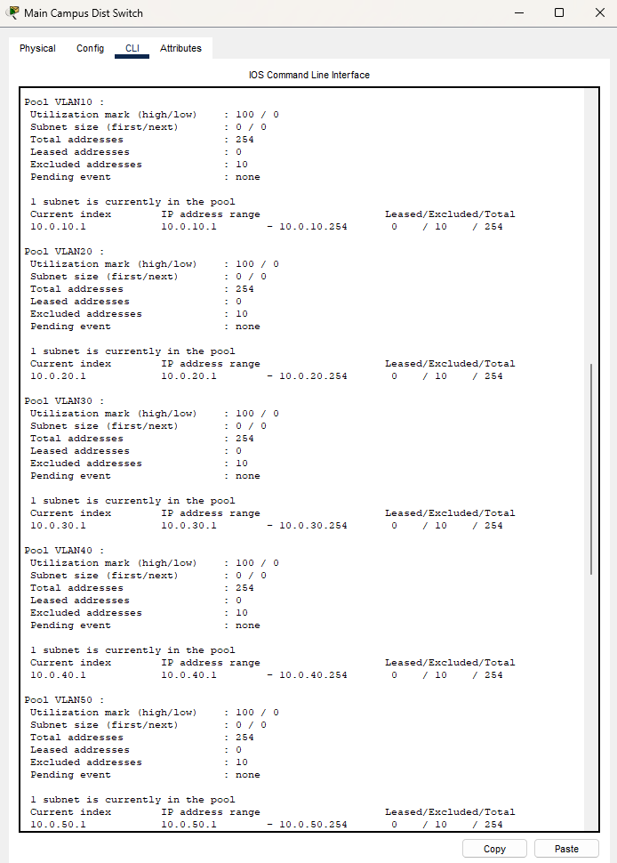

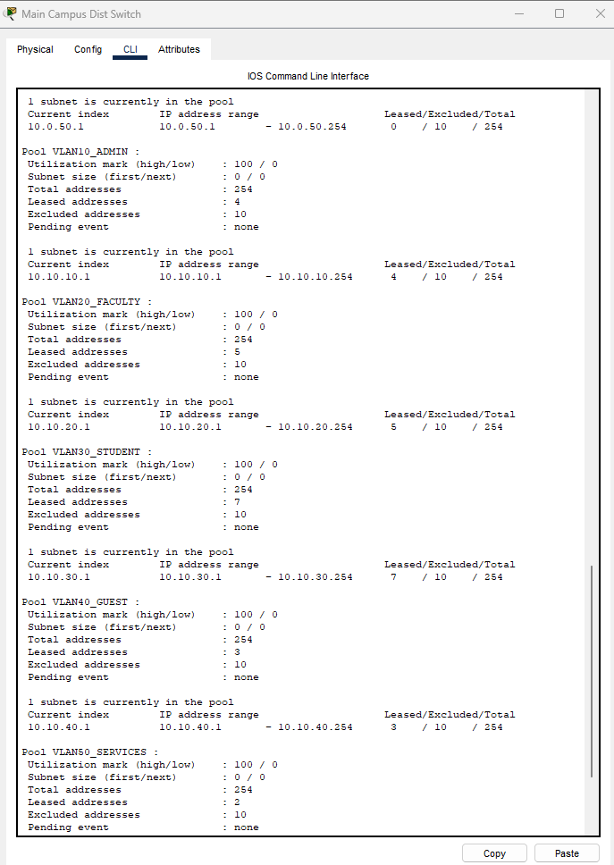
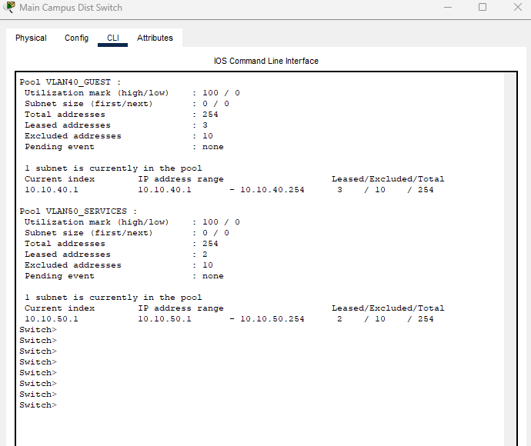

3. Inter-VLAN Routing Test
From any PC (for example, an Admin PC), test connectivity between VLANs:
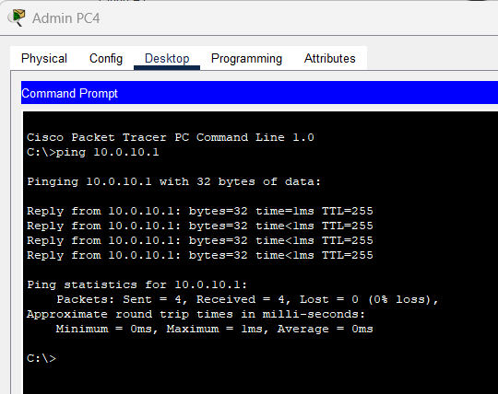
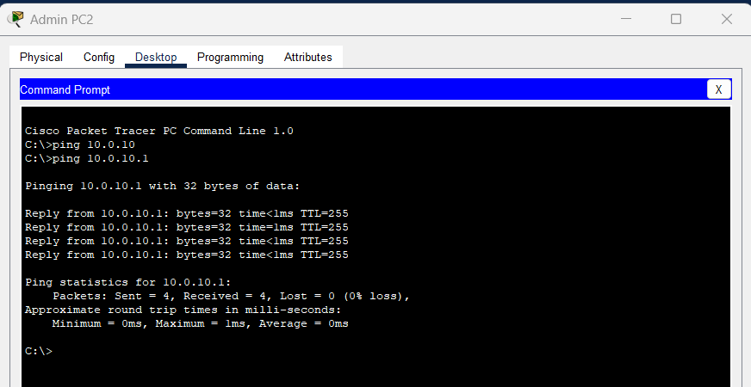

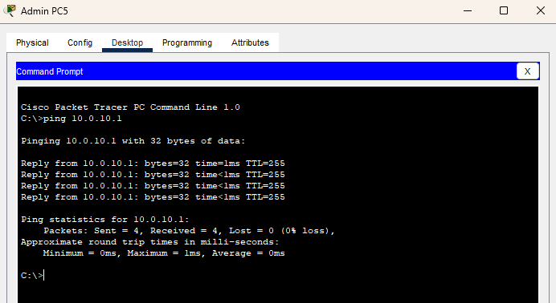

4. End-to-End Device Testing
Student PC 1 Admin PC 1
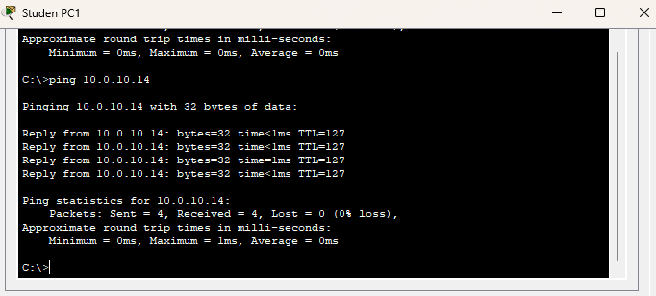
Confirm all devices can reach each other. From Admin PC, ping:
ping 10.0.30.11 (Student Laptop)
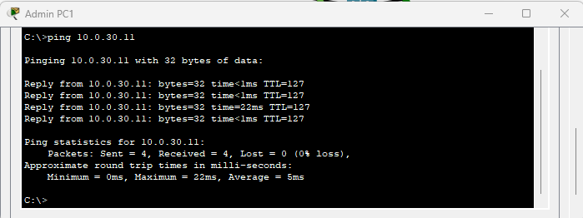
ping 10.0.40.12 (Guest Laptop)
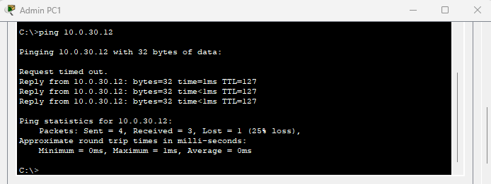

ping 10.0.50.10 (Email Server)
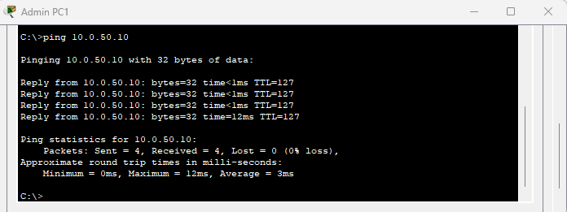
ping 10.0.50.20 (Authentication Server)
From Student Laptop, ping:
ping 10.0.10.11 (Admin PC)
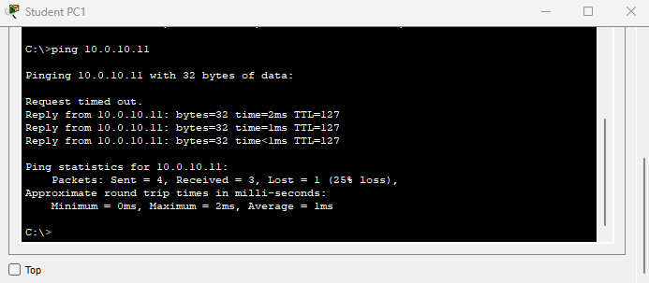
ping 10.0.20.11 (Faculty PC)
5. Server VLAN (50) Test
From Faculty PC, verify communication with both servers:
ping 10.0.50.10 (Email Server)
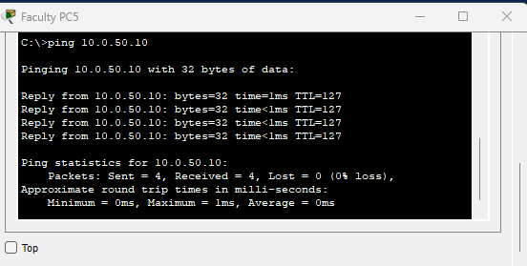
ping 10.0.50.20 (Authentication Server)
From each server, confirm it can reach all gateways:
ping 10.0.10.1
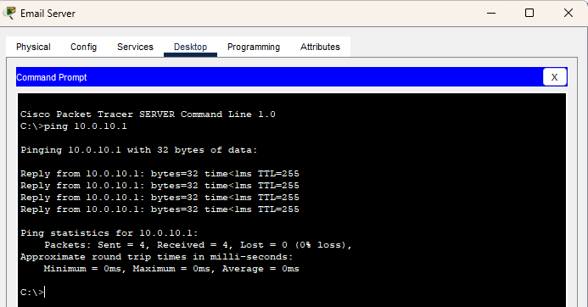

ping 10.0.20.1
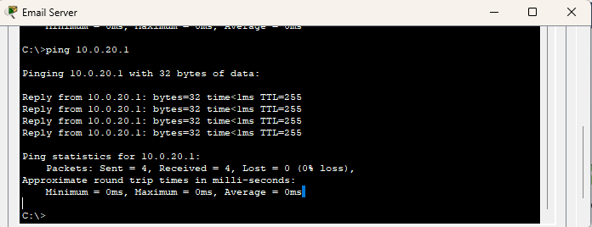
ping 10.0.30.1
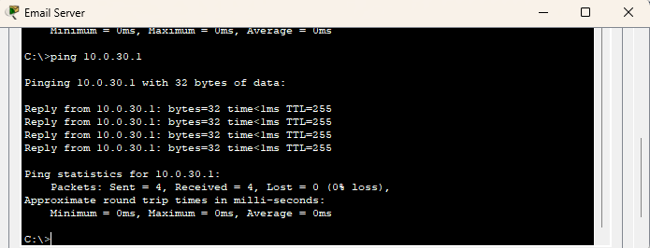
ping 10.0.40.1
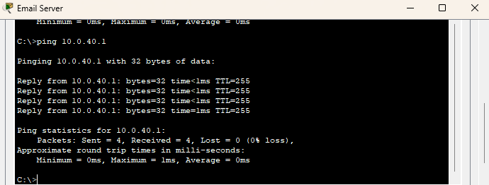
ping 10.0.50.1
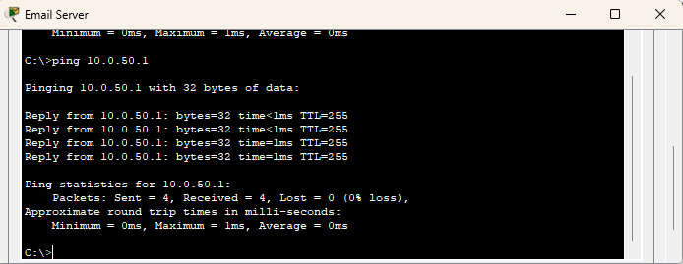
6. Internet Simulation (Optional)
If routers and Cloud are configured, confirm external routing:
ping 8.8.8.8
If unsuccessful, check static routes using 'show ip route' and correct next-hop addresses on each router.
7. Save and Document
Once testing passes, save configurations and take screenshots for your report:
wr mem
Required Screenshots:
- show vlan brief
- show interfaces trunk
- show ip dhcp binding
- Ping tests between VLANs and servers
- DHCP confirmation on PCs and laptops
Save the Packet Tracer file as 'Project1_Final_Network.pkt'.

